**TECHNICAL DOCUMENTATION**

|  |  |  |  |
| --- | --- | --- | --- |
| Project Name | Project Owner | Project Client | Project Developer |
| Event creation form | Barath Kumar | Inwiter | Barath Kumar |

TABLE OF CONTENTS

1. Use of this document………………………………………………………………………………………… 1
2. Introduction about project………………………………………………………………………
3. Description about project

1. Use of this document.

This document is used for understanding technically what is going on in this project.

1. Introduction about project.

This project is used to store the events(occasions) temporarily in tabular form.

1. Description about project.

First we will see the below interface.

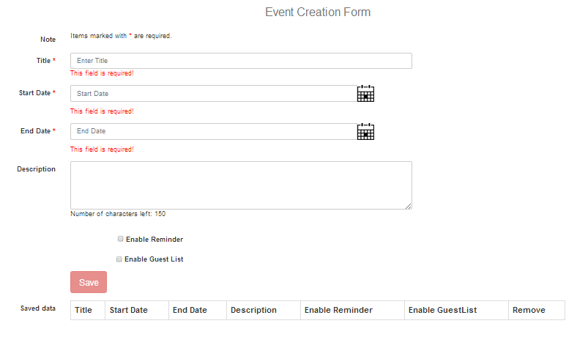

In the about interface there is three mandatory fields those are Title, Start Date and End Date. First we should fill these fields like below interface.

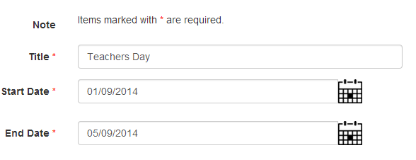

After properly filled these fields save button will be changed to green color and enable mode. See bellow interface.

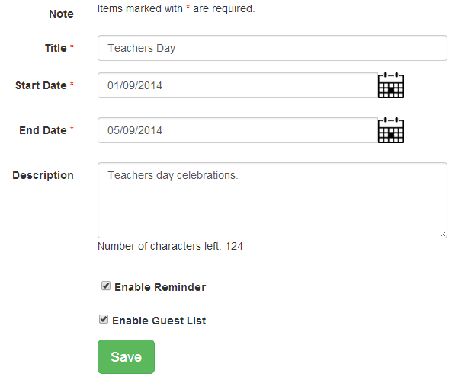

Finally click on save button to store data in below table. Check the below interface.

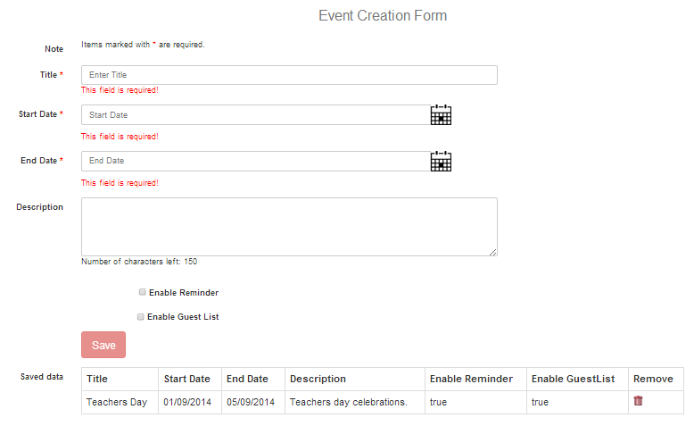

In the above interface event data saved in table, if you want to remove to click on dustbin symbol in table.